Contents

***ACKNOWLEDMENTS*** 4

CERTIFICATE 5

Problem Definition 6

Requirements of the project 6

***Problem Definition*** 9

***Project Specifications*** 9

User Roles and Functionalities 10

**Functional Specifications** 11

• Dashboards: Comprehensive views for admins and users. 11

• Forms: Facilitate order placement, product management, and user registration. 11

• Tables: Display records with search and pagination functionalities. 11

*Database Design Structure:* 20

*Displays The ER Diagram Of The Application* 28

*Checklist of validations* 31

*Submission Checklist* 32

*Our Solution* 33

Screen Grap of the Website 34

Login page for user 34

Home page 34

About us 36

Schemes Plan Page 37

Plan Page 37

plan and schemes subscribed by the user 38

Frequently Asked Questions 39

Feedback 39

User Profile 40

History of plan subscribed 40

Track Your Plan Connection 41

Track Your Schemes Connection 41

Waited page 42

Admin Panel 43

Dash-Board of Admin panel 43

Add New Admin 43

The details of Admin 44

Add New Retail Store 44

The details of Retail Stores 45

Add New Product 45

The details of products 46

Add New designation for employee 46

The details of designation for employee 47

The Details of Employees 47

Add New Plan Connection 48

The Details of Plan Connection 48

The Details of Plan Connection subscribed by User 49

The Details of Plan Connection subscribed by outlet employee 49

Add New Vendor 50

The Details of Vendor 50

The Details of Vendor 51

Add New Schemes 51

The Details of Schemes 52

The Details of Schemes Subscribed by user 52

The Details of Schemes Subscribed by user 53

The Details of Schemes Subscribed by outlet Employee 53

The Details of Contact 54

Add New FAQ 54

The Details of FAQ 55

Feedback List 55

Accountant Panel 55

Account Dashboard 56

The Details of plan connection by the user 56

The Bill Generate of plan connection by the user 56

The Details of Schemes Subscribed by The User 57

Technical Panel 58

The Dashboard of technical panel 58

*Task Sheet for Nexus Marketing System Project:* 65

*Work Breakdown Chart* 66

*conclusion* 67

# ***ACKNOWLEDMENTS***

**We wanted to take a moment to express my sincere appreciation for your guidance and support for Ma’am LARAIB. Your mentorship has had a profound impact on my growth, and I am truly grateful for your wisdom and encouragement.**

**We also want to appreciate my institution APTECH METRO STAR GATE to give us an opportunity for grooming our skills and give us a professional platform to enter in the world of advancement**

**Thank you,**

## CERTIFICATE

## Problem Definition

The existing manual processes for handling customer orders, billing, and record maintenance in the communication sector were inefficient and prone to errors, leading to delays and customer dissatisfaction.

The bill is to be generated by the accounts department and should be updated in the application so that one can access the bill through the website. The payment details should be clearly mentioned by the system indicating the amount paid and due amount. And the details of the charges levied for a particular plan, the details of the plans are to be maintained by the admin.

## Requirements of the project

The various plan details are as follows.

Security Deposit: It is the charge that will be refunded back to the customer during the time of withdrawal or cancellation. In general it will be charged as follows for the type of the connection

Dial – Up Connection : 325$

Broad Band Connection : 500$

LandLine Connection : 250$

Dial – Up Connection :

Hourly Basis

10 Hrs. – 50$ (validity is for one Month)

30 Hrs. – 130$ (validity is for 3 Months)

60 Hrs. – 260$ (validity is for 6 Months)

Unlimited 28Kbps.

Monthly – 75$

Quarterly – 150$

Unlimited 56 Kbps.

Monthly – 100$

Quarterly – 180$

Broad Band Connection

Hourly Basis

30 Hrs. – 175$ (validity is for 1 Month)

60 Hrs. – 315$ (validity is for 6 Months)

Unlimited 64Kbps.

Monthly – 225$

Quarterly – 400$

Unlimited 128 Kbps.

Monthly – 350$

Quarterly – 445$

Land Line Connection

Local Plan = Rental + Call charges

Unlimited - 75$ (Valid for an year and this is the rental)

The call charges are like this : 55cents / minute

Monthly Plan – 35$ (Valid for a month and this is the rental)

The call charges are like this : 75cents / minute

STD Plan :

Monthly – 125$ (Valid for a month and this is the rental)

The call charges are like this :

Local : 70cents / minute

STD : 2.25$ / minute

Messaging For Mobiles : 1.00$ / Minute

Half - Yearly – 420$ (Valid for a month and this is the rental)

The call charges are like this :

Local : 60cents / minute

STD : 2.00$ / minute

Messaging For Mobiles : 1.15$ / Minute

Yearly – $ (Valid for an year and this is the rental)

The call charges are like this :

Local : 60cents / minute

STD : 1.75$ / minute

Messaging For Mobiles : 1.25$ / Minute

The service tax is as per the government (12.24%) on the whole bill generated and will be charged to the customer.

Functional Requirements : –

Creation, maintenance and updating database, which contains

Information Regarding the various plans

Details of retail stores

Details of the employees

Details of customers, vendors are needed to be updated.

Details of the orders generated

Details of the products

Details of the materials provided with the customer

Maintaining the records of the orders generated for the customer regarding the connection, and the products, also the feedback from the customer is to be collected

The billing for the order is to be calculated taking into account the customer entitlements in terms of discount and schemes chosen and the payment done previously

***Problem Definition***

Nexus Communication System is an Organization system that provides two services like the tele-communications and Internet Services. It is one of the major vendors at the local place. It has now extended its service all over the territory due to the increase in demand for the internet service.

***Project Specifications***

**Overview**

The Nexus Communication System Automation project aims to create an online application that automates customer order management, billing processes, and record maintenance. The application supports multiple user roles, each with specific functionalities to ensure smooth and efficient operations.  
  
**Technology Stack**

- Backend Framework: ASP.NET Core MVC  
- Database: SQL Server  
- Frontend Framework: Bootstrap, JavaScript  
- Development Tools: Visual Studio (free edition), SQL Server

Management Studio (SSMS)  
  
**Key Modules**

**1**. **Order Management Module:**  
 - Order Placement: Users can place new orders through an intuitive form.  
 - Order Tracking: Users can view the status of their orders.  
 - Order Management: Admins can view and update order statuses.  
  
**2**. **Billing Module:**  
 - Billing Calculation: Automated calculation based on usage and selected plans.  
 - Invoice Generation: Generate and send invoices to customers.  
 - Payment Tracking: Track payments and manage billing records.  
  
**3**. **User Management Module:**  
 - Admin Management: CRUD operations for admin accounts.  
 - User Registration and Management: CRUD operations for user accounts.  
 - Employee Management: CRUD operations for employee accounts.  
  
**4**. **Product and Vendor Management Module:**  
 - Product Management: Admins can add, update, and delete products.  
 - Vendor Management: Admins can manage vendor details and relationships.  
  
**5**. **Record Maintenance Module:**  
 - Customer Records: Maintain detailed records of all customers.  
 - Vendor Records: Keep track of all vendors and their products.  
 - Product Records: Manage the product catalog and inventory.

## User Roles and Functionalities

1. **Admin Role:**  
 - Access to all modules and functionalities.  
 - Manage products, vendors, retail shops, connection plans and admins.  
 - Perform CRUD operations across all records.  
 - View and manage orders and billing.  
  
2. **User Role:**  
 - Place and track orders.  
 - View billing details and make payments.  
 - Manage personal information.  
  
3. **Employee Role:**  
 - Access specific modules as assigned.  
 - Perform CRUD operations on assigned records.  
 - Assist in order processing and record maintenance.  
  
**User Interface Specifications:**

* Dashboards: Provide a comprehensive overview for admins and users, including key metrics and recent activities.
* Forms: Simplified and user-friendly forms for order placement, product management, and user registration.
* Tables: Display records with search and pagination features for easy navigation and management.
* Responsive Design: Ensure the application is accessible and functional across various devices and screen sizes using Bootstrap.  
    
  **Security Specifications**
* Authentication and Authorization: Implement secure login and role-based access control.
* Data Encryption: Protect sensitive data both in transit and at rest.
* Audit Logs: Maintain logs of user activities for security and compliance.  
    
  **Performance Specifications**
* Optimized Queries: Use efficient SQL queries to ensure quick data retrieval.
* Scalability: Design the application to handle increasing amounts of data and users.
* Load Testing: Perform load testing to ensure the application can handle high traffic.

**Functional Specifications**

* Dashboards: Comprehensive views for admins and users.
* Forms: Facilitate order placement, product management, and user registration.
* Tables: Display records with search and pagination functionalities.

## 

**Customer Requirement Specification (CRS)**

**Client:** Regal Soft Application

**Business/Project Objective**

The objective of the Nexus Communication System Automation project is to develop an online application that streamlines the processes of customer order management, billing, and record maintenance for communication sector organizations. The system aims to enhance efficiency, accuracy, and customer satisfaction by automating these processes.

**Project Overview**

The project addresses various aspects of the communication business, including order management, customer details, vendor management, product catalog, and billing. The system is expected to cater to the specific needs of the client, ensuring seamless integration with their existing processes and delivering a user-friendly experience.

**Inputs Provided by the Client**

* **Existing System Data:**
  + - Data on current orders, customer records, vendor details, and products.
* **Business Requirements:**
  + - Detailed requirements for order processing, billing calculations, and record maintenance.
* **User Roles and Permissions:**
  + - Specifications for different user roles (admins, users, employees) and their respective permissions.
* **Expected Delivery Dates:**
  + - Timeline for project milestones and final delivery.
* **List of Deliverables:**
  + - Comprehensive list of expected deliverables including software modules, documentation, and training materials.

**Inputs to the Existing System**

* **Order Information:**
  + - Data related to new and existing customer orders.
* **Customer Details:**
  + - Comprehensive customer information for accurate record maintenance.
* **Product and Vendor Information:**
  + - Data on products and vendors for effective management.

**Outputs from the Existing System**

* **Order Status Reports:**
  + - Real-time updates on order processing and fulfillment.
* **Billing Statements:**
  + - Accurate billing information generated based on customer usage and selected plans.
* **Customer Records:**
  + - Detailed records of customer interactions, orders, and payments.

**Process Involved in the Application**

* **Order Management:**
  + - Automating the process of receiving, processing, and tracking customer orders.
* **Billing:**
  + - Calculating and managing billing based on usage and selected plans, generating invoices, and tracking payments.
* **User Management:**
  + - Managing user accounts, roles, and permissions.
* **Product and Vendor Management:**
  + - Maintaining product catalog and vendor details.
* **Record Maintenance:**
  + - Keeping detailed and accurate records of customers, vendors, and transactions.

**List of Deliverables**

* **Functional Modules:**
  + - Order management, billing, user management, product and vendor management, record maintenance.
* **Documentation:**
  + - Project documentation, user manuals, technical guides.
* **Training Materials:**
  + - Training sessions and materials for users and administrators.

**Scope of the Work (in Brief)**

Develop an online system using ASP.NET Core MVC and SQL Server to automate order management, billing, and record maintenance, catering to different user roles including admins, users, and employees.

***Displays the Context level diagram:***

***Nexus Communication, System Automation***

***Application***

***Manages***

***Products***

***Vendors***

***Retail***

***Shops***

***Schemes***

***Admins***

***Connection plans***

***CRUD Operations***

***User***

***Performs***

***Crud Operations***

***Places Orders***

***Admin***

***Employee***

***Customer***

***Performs***

***Crud Operations***

***Places Orders***

***Places Orders***

***Performs***

***CRUD Operations***

***Manages Retail Shops Products plan and bill generates***

***Receives Order Confirmations &Bills***

***Displays the first level of data flow diagram:***

**Database**

- Store Data

- Retrieve Data

**Database**

- Store Data

- Retrieve Data

**Scheme Management**

- Manage Schemes

- Store/Retrieve Data

**Vendor Management**

- Manage Vendors

- Store/Retrieve Data

**Retail Shop Manage**

- Manage Retail Shops

- Store/Retrieve Data

**Product Management**

- Manage Products

- Store/Retrieve Data

**Database**

- Store Data

- Retrieve Data

**Billing and Record Keeping**

- Store Bill Data

**Order Management**

- Process Order

- Send Confirmation

- Generate Bill

***Customer***

***Admin***

***Staff***

***Displays data flow diagram of***

***customer and account information:***

**Database**

- Store Account Info

- Retrieve Account Info

- Retrieve Customer Info

**Database**

- Store Customer Info

- Store Account Info

- Retrieve Customer Info

**Account Retrieval**

- Retrieve Account Info

**Account Deletion**

- Delete Existing Account

**Account Update**

- Update Existing Account

-Create a New Account

**Account Creation**

- Create New Account

**Account Manager**

- Validate Account

- Handle CRUD Ops

**Customer Information Management**

- Collect Info

- Update Info

***Customer***

***Admin***

***Displays the second level DFD for information retrieval and storage***

Insert/Update Account Data in Database

***Customer/Admin***

***Customer/Admin***

Insert/Update Customer Data in Database

***Customer/Admin***

***Customer/Admin***

***Customer/Admin***

***Customer/Admin***

***Customer/Admin***

Validate Retrieval Request

Fetch Customer Data from Database

Return Customer Data

Validate Retrieval Request

Fetch Account Data from Database

Return Account Data

Validate Storage Request

Confirm Storage

Validate Storage Request

Confirm Storage

***Displays the Flow*** ***diagram of nexus for authentication***

Authentication Successful?

Log Attempt

Error Page

User

Dashboard

Database

Fetch User Data

Validate Credentials

Authentication Server

Login Page

***User Customer/Admin Employee***

## *Database Design Structure:*

The structure of tables is given below

|  |  |  |  |
| --- | --- | --- | --- |
| Table of User | | | |
| Field Name | Data Type | Key | Description |
| User Id | Int | PK | Store the identification code of user |
| User Name | nchar |  | Store the name of user |
| User password | nchar |  | Store the email of user |
| User status | Int |  | Store the user status in numerical from |
| Status updates | nchar |  | Store the user status in alphabetical from |

|  |  |  |  |
| --- | --- | --- | --- |
| Table of Admins | | | |
| Field Name | Data Type | Key | Description |
| User Id | Int | PK | Store the identification code of admin |
| User Name | Nvarchar |  | Store the name of admin |
| User password | Nvarchar |  | Store the email of admin |
| User status | Int |  | Store the admin status in numerical from |
| Status updates | nvarchar |  | Store the admin status in alphabetical from |

|  |  |  |  |
| --- | --- | --- | --- |
| Table of Vendors | | | |
| Field Name | Data Type | Key | Description |
| Id | Int | PK | Store the identification code of Vendor |
| Vendor Name | Nvarchar |  | Store the name of vendor |
| Vendor Email | Nvarchar |  | Store the email of vendor |
| Vendor Number | Int |  | Store the number of vendor |

|  |  |  |  |
| --- | --- | --- | --- |
| Table of Plans | | | |
| Field Name | Data Type | Key | Description |
| Id | Int | PK | Store the identification code of Plan |
| Name | nvarchar |  | Store the name of plan |
| Type | Nvarchar |  | Store the type of plan |
| Description | nvarchar |  | Store the Description of plan |
| Charges | int |  | Store the charges or price of the plan |
| Status | int |  | Store the status value of numerical of plan |
| Status updates | Nvarchar |  | Store the status value of alphabetical of the plan |

|  |  |  |  |
| --- | --- | --- | --- |
| Table of Packages(schemes) | | | |
| Field Name | Data Type | Key | Description |
| Id | Int | PK | Store the identification code of schemes |
| Scheme Name | nvarchar |  | Store the name of scheme (packages) |
| Scheme count | Nvarchar |  | Store the numbers of  Schemes |
| Scheme Des | Nvarchar |  | Store the Description of  Schemes |
| Price | Int |  | Store the charges or price of the schemes |
| percentage | Int |  | Store the value of percentage of discount available for schemes |
| Discount | Int |  | Store the discount value |

|  |  |  |  |
| --- | --- | --- | --- |
| Table of FAQ(frequently asked questions) | | | |
| Field Name | Data Type | Key | Description |
| Id | Int | PK | Store the identification code of Faq |
| Faq_ques | nvarchar |  | Store the question of FAQ |
| Faq_ans | Nvarchar |  | Store the answers of  FAQ |

|  |  |  |  |
| --- | --- | --- | --- |
| Table of Position | | | |
| Field Name | Data Type | Key | Description |
| Id | Int | PK | Store the identification code of Position |
| Faq_ques | nvarchar |  | Store the name of position available for employee |

|  |  |  |  |
| --- | --- | --- | --- |
| Table of Employee | | | |
| Field Name | Data Type | Key | Description |
| Id | Int | PK | Store the identification code of Employee |
| Name | nvarchar |  | Store the name of employee |
| Email | nvarchar |  | Store the Email of employee |
| Phone | int |  | Store the phone number of employee |
| Address | nvarchar |  | Store the address of employee |
| User_Name | nvarchar |  | Store the user name of employee that is provided by admin |
| User_Password | nvarchar |  | Store the user password of employee that is provided by admin |
| Age | int |  | Store the Age of employee |
| Gender | nvarchar |  | Store the gender of employee |
| status | int |  | Store the numerical value of status of employee |
| Status_update | nvarchar |  | Store the alphabetical value of status of employee |
| Position_Id | int | FK | Store Id of the foreign key form the table of position |

|  |  |  |  |
| --- | --- | --- | --- |
| Table of Retail Store | | | |
| Field Name | Data Type | Key | Description |
| Id | Int | PK | Store the identification code of Retail store |
| Name | nvarchar |  | Store the name of retail stores |
| City | nvarchar |  | Store the city of retail stores |
| Area | nvarchar |  | Store the Area of retail Stores |
| contact | int |  | Store the phone number of retail stores |

|  |  |  |  |
| --- | --- | --- | --- |
| Table of products | | | |
| Field Name | Data Type | Key | Description |
| Id | Int | PK | Store the identification code of product |
| Name | nvarchar |  | Store the name of product |
| Description | nvarchar |  | Store the description of products |
| Image | nvarchar |  | Store the Image of products |
| price | int |  | Store the price of products |
| Quantity | int |  | Store the quantity of products |
| Retail_store_id | int | FK | Store the id of the foreign key form the table of position |

|  |  |  |  |
| --- | --- | --- | --- |
| Table of feedback | | | |
| Field Name | Data Type | Key | Description |
| Id | Int | PK | Store the identification code of feedback |
| User_name | nvarchar |  | Store the name of user |
| User_email | nvarchar |  | Store the email of user |
| massage | nvarchar |  | Store the massage of user |

|  |  |  |  |
| --- | --- | --- | --- |
| Table of Contact | | | |
| Field Name | Data Type | Key | Description |
| Id | Int | PK | Store the identification code of feedback |
| User_name | nvarchar |  | Store the name of user |
| User_email | nvarchar |  | Store the email of user |
| User_msg | nvarchar |  | Store the massage of user |

|  |  |  |  |
| --- | --- | --- | --- |
| Table of Plan Subscribed | | | |
| Field Name | Data Type | Key | Description |
| carttocartId | Int | PK | Store the identification code of plan subscribed |
| Order_id | nvarchar |  | Store the order id of plan subscribed with unique alphabetic code |
| Plan_name | nvarchar |  | Store name of connection plan that is subscribed by user |
| User_name | nvarchar |  | Store the name of user |
| User_email | nvarchar |  | Store the email of user |
| User_number | nvarchar |  | Store the number of user |
| paymentofmode | nvarchar |  | Store the payment of mode that is used by user for subscribed the connection plan |
| pincode | nvarchar |  | Store the pincode of user |
| user_address | nvarchar |  | Store the address of user |
| charges | int |  | Store the price of connection plan |
| status | int |  | Store the numerical value of status |
| status_updates | nvarchar |  | Store the alphabetical value of status |
| GenerateBillstatus | int |  | Store the numerical value of Generate bill status |
| GenerateBillstatus_update | nvarchar |  | Store the alphabetical value of Generate bill status |
| payment | nvarchar |  | Store the history of payment of user |
| FeasibilityStatus | nvarchar |  | Store the feasibility status of plan |
| date | nvarchar |  | Store thedatewhen the connection is provided by our employee |
| Contact | nvarchar |  | Store the contact of employee for acknowledgment about the connection plan |
| productType | nvarchar |  | Store the type of router given with the connection plan |

|  |  |  |  |
| --- | --- | --- | --- |
| Table of Schemes Subscribed | | | |
| Field Name | Data Type | Key | Description |
| Order_id | nvarchar |  | Store the order id of schemes subscribed with unique alphabetic code |
| Plan_name | nvarchar |  | Store name of schemes that is subscribed by user |
| User_name | nvarchar |  | Store the name of user |
| User_email | nvarchar |  | Store the email of user |
| User_number | nvarchar |  | Store the number of user |
| paymentofmode | nvarchar |  | Store the payment of mode that is used by user for subscribed the  schmes |
| pincode | nvarchar |  | Store the pincode of user |
| charges | int |  | Store the price of connection plan |
| discount | int |  | Store the discount that is availed by user |

## *Displays The ER Diagram Of The Application*

Database structure of different tables is given following sections.

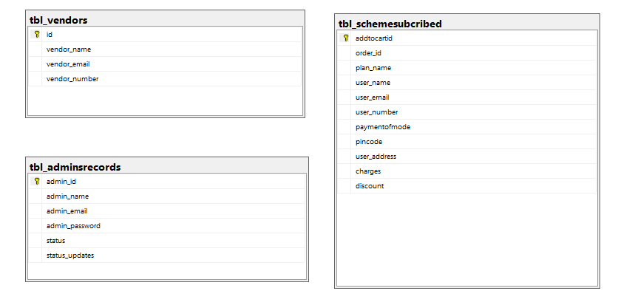

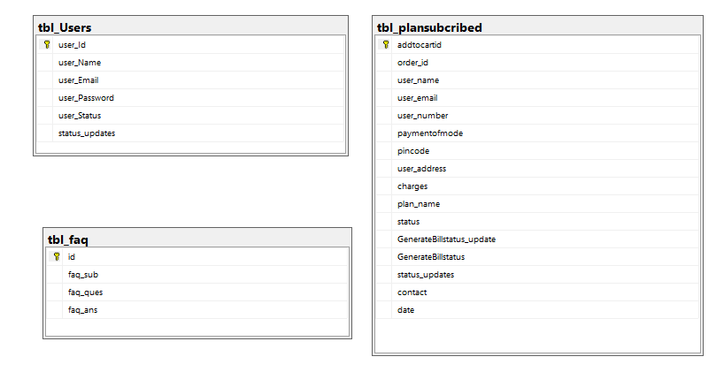

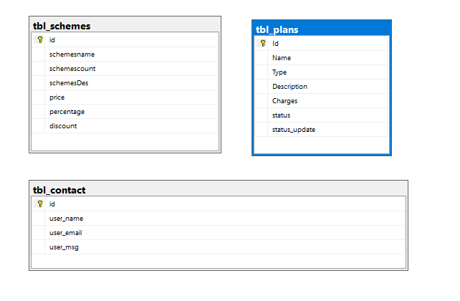

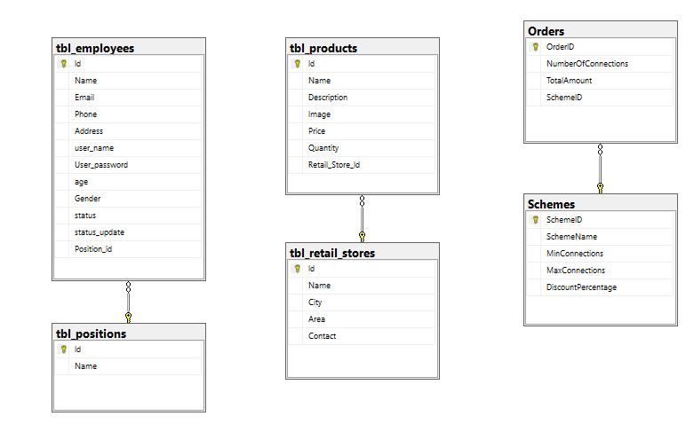

## *Checklist of validations*

The checklist of validation of project is given below;

|  |  |
| --- | --- |
| Options | Validate |
| Does administrator have all the right to create and delete the record ? | Yes |
| Are all the records properly fed into the appropriate database? | Yes |
| Have all the design and coding standards been followed and implemented ? | Yes |
| Is the design consistent all the over? | Yes |
| Is the navigation sequences correct through all the screens in the application ? | Yes |
| Are all the program codes working? | Yes |

## *Submission Checklist*

The submission checklist of project is given below

|  |  |  |  |  |  |
| --- | --- | --- | --- | --- | --- |
| Sr.NO | Particular | Yes | No | NA | Comments |
| 1 | Are all the user able to search for a particular record? | Yes |  |  | The search functionality is properly working . |
| 2 | Are all the old records properly saved and retrieved when required ? | Yes |  |  |  |
| 3 | Are all the code working as per the specification? | yes |  |  | All the specification are properly tested and it worked successfully . |
| 4 | Are the GUI content devoid of spelling mistakes? | yes |  |  | Yes the website have no spelling mistake in GUI . |
| 5 | Is the application user-friendly ? | yes |  |  | Yes the feature of website are easy to understood by the User . |
| 6 | Is the project published properly into a setup file ? | yes |  |  |  |

## *Our Solution*

Nexus Communication System aims to streamline its operations and enhance efficiency by developing an online application to automate record-keeping processes. This application will feature separate logins for administrators and employees, facilitating distinct functionalities tailored to their roles.

Administrators will have access to input and update employee details, stock information, vendor records, and retail shop data. On the other hand, employees will be able to place orders, monitor order statuses, view bills, update contact information, and gain insights into available plans.

When a customer places an order for a connection, they will receive a unique 11-digit order ID, which allows them to track the status of their order. Once the connection is established, customers will be assigned a unique 16-digit account ID, incorporating coding that denotes the type of connection, city code, and serial connection number.

Advanced search options will enable users to search for orders or connections based on various criteria such as unique IDs, customer names, connection types, application dates, and contact numbers.

Currently, Nexus Communication System offers post-paid connections, with bills generated based on the chosen plan and equipment usage. An accounts department login will be available for calculating charges and updating billing details on the system.

Customers will have their own login portal where they can view and update their contact details, place orders, track order statuses, and review bills. They can utilize their unique order ID to check the status of their order and their unique account ID to monitor connection status.

To support this system, a comprehensive database will store equipment details, vendor information, employee records, customer data, connection details, and order information. This database will serve as the backbone of the automated system, allowing Nexus to efficiently manage customer queries and meet their needs effectively.

## Screen Grap of the Website

### Login page for user

### Home page

## 

## 

## 

### About us

## 

### Schemes Plan Page

### 

### Plan Page

## 

### **plan and schemes subscribed by the user**

## 

### **Frequently Asked Questions**

### Feedback

### 

### **User Profile**

### History of plan subscribed

## 

### Track Your Plan Connection

## 

### Track Your Schemes Connection

### Waited page

Note: this page is appeared when the user, admin or employee account is deactivated by admin

## Admin Panel

## Dash-Board of Admin panel

## 

### Add New Admin

## 

### 

### The details of Admin

### Add New Retail Store

## 

### The details of Retail Stores

## 

### Add New Product

## 

## 

### The details of products

## 

### Add New designation for employee

## 

### The details of designation for employee

### The Details of Employees

### Add New Plan Connection

### The Details of Plan Connection

### The Details of Plan Connection subscribed by User

## 

### The Details of Plan Connection subscribed by outlet employee

## 

### Add New Vendor

## 

### The Details of Vendor

### The Details of Vendor

### Add New Schemes

### 

### The Details of Schemes

## 

### The Details of Schemes Subscribed by user

## 

### The Details of Schemes Subscribed by user

## 

### The Details of Schemes Subscribed by outlet Employee

### The Details of Contact

### Add New FAQ

### The Details of FAQ

## 

### Feedback List

## 

## Accountant Panel

### Account Dashboard

## 

### The Details of plan connection by the user

## 

### The Bill Generate of plan connection by the user

## 

### The Details of Schemes Subscribed by The User

### 

## Technical Panel

### The Dashboard of technical panel

## 

## 

## 

## 

## 

## 

## 

## 

## 

## 

## 

## 

## 

## 

## 

## *Task Sheet for Nexus Marketing System Project:*

|  |  |  |  |  |  |
| --- | --- | --- | --- | --- | --- |
| **Task ID** | **Description** | **Assigned To** | **Start Date** | **Due Date** | **Status** |
| 1 | Design ER Diagram | Falak Naz | 2024-07-21 | 2024-07-22 | Completed |
| 2 | Develop Customer Module | Aakash & Falak Naz | 2024-07-23 | 2024-07-25 | Completed |
| 3 | Implement Authentication System | Mahnoor Anwar | 2024-07-26 | 2024-07-28 | Completed |
| 4 | Create Order Management System | Mahnoor Anwar | 2024-07-29 | 2024-07-31 | Completed |
| 5 | Setup Database | Mahnoor Anwar | 2024-08-01 | 2024-07-03 | Completed |
| 6 | Develop Admin Panel | Falak Naz | 2024-08-04 | 2024-07-06 | Completed |
| 7 | Test and Debug | Falak Naz | 2024-08-07 | 2024-07-09 | Completed |
| 8 | Finalize Documentation | Mahnoor Anwar | 2024-08-10 | 2024-07-12 | Completed |

## *Work Breakdown Chart*

|  |  |  |
| --- | --- | --- |
| Phase | Days | Teammate |
| **Analysis** | 4 Days | Falak Naz, Mahnoor Anwar and Akash |
| **Planning** | 5 Days | Falak Naz, Mahnoor Anwar and Akash |
| **Development** | 19 Days | Falak Naz and Mahnoor Anwar |
| **Testing** | 2 Days | Falak Naz, Mahnoor Anwar and Akash |

## *conclusion*

In conclusion, the implementation of an online application by Nexus Communication System marks a significant step towards modernizing its operations and enhancing customer service. By automating record-keeping processes and providing tailored functionalities for administrators, employees, and customers, Nexus aims to streamline its workflow and improve efficiency. A comprehensive database to store vital information, Nexus is poised to better respond to customer queries and meet their needs promptly. This initiative underscores Nexus's commitment to innovation and customer satisfaction in an increasingly digital age.

“***JAZAKALLAH”***

“***Thank You”***